Hospice costing model
  - Quick Start
The purpose of the model is to calculate the actual cost of your services for the previous financial year. The model is designed for you to work through each tab of the excel spreadsheet in order (there are a couple of optional worksheets – the model still works if you don’t complete those sheets). The first two pages of this guide are a quick start guide which summarises the model at a high level. The remainder of this document is a detailed step by step guide for each stage of the model – people who have not used the model before may want to refer to this, while others may just need to dip into for specific guidance.
Workbook cells are colour coded as follows: Yellow = essential or conditional input. Blue with a border = OPTIONAL input. Grey = calculated or fixed (do not enter data).

Before you open the workbook
- Gather consolidated expenditure, service and support costs, staff information, floor space, meals, activity and capacity data. Use actual figures for the latest completed financial year.
- Read the service definitions at the end of this guide. Select only services your hospice provides

Complete the core return
Tab in excel workbook | What to do
02 Hospice Setup | Enter hospice name, dates you are entering data for, total expenditure, active sites (the model now supports up to 3 sites) and services your hospice provides
03 Catering Adjustment | Enter annual catering costs and paid/free meal numbers if you have catering costs – this adjustment removed cost of paid for meals from the calculations
04 Service Costs | Costs are entered across three worksheets – this sheet is for entering direct service costs. For each service, costs are entered in 3 categories: doctors costs, all other staff costs and non staff costs
05 Support & Income Generation Costs | This is the second cost entry sheet – for support costs and income generation costs . Catering costs are automatically populated from worksheet 3.
06 Shared Cost Pools | The third cost entry sheet is for care costs that don’t relate only to one service – e.g. medical director or clinical governance that need to be split across services. Enter the actual costs in the top table, and then the basis for splitting the cost across services in the bottom table on this worksheet.
07 Support Drivers / 08 Allocation Data | Sheet 7 allows you to override the default method for allocation overheads if you think another method is more appropriate; sheet 8 is where you enter the data to drive the overhead reallocations (e.g. staff numbers, floor space)
09 Core Activity & Capacity | Enter actual activity and (where relevant) capacity for each service. Add annual unique service users if reliable figures are available.

Quick start

Consider optional detail before reviewing results
Optional tab | What it adds and what it needs
10 Optional IPU Care Type | This is a more detailed optional worksheet, completing it enables us to estimate costs by adult IPU care type. It needs annual bed nights by care type, plus data on how nurses spend their time in a representative period (week or month)
11 Optional Community | This is a more detailed optional worksheet, completing it enables us to estimate community care costs in more detail split between estimated telephone and face-to-face costs. It needs contact counts plus total paid staff hours or average paid staff minutes per contact.
12- Checks & Analysis | Worksheet 12 is for completion and error checking, 13 & 14 show the core results and 15 shows the enhanced results analysis where completed.

Review and return
- Open 12 Checks & Completion. Resolve errors, review warnings and investigate any unexplained cost differences. Email c.duncan@hospiceuk.org if you are unable to resolve any errors yourself.
- Review 13 Results Dashboard and 14 Detailed Results. Check unexpected results against your accounts, service model and activity. Save with your hospice name and reporting year, then return to c.duncan@hospiceuk.org

Five rules that prevent common problems
- Enter each cost once. Do not duplicate a shared-pool cost in a service or central support, and do not re-enter catering costs on 05 Support & Income Generation (as they are already automatically calculated based on the info entered in Sheet 02)
- Include employment on-costs and agency staff in staff costs. Record paid medical input under doctors. Do not put a value on medical input supplied free of charge; record that only as optional info in the free text box
- Outpatient and community capacity may be left blank if you consider capacity meaningless for those services – we will focus costing analysis on activity for these areas.
- IPU results use cost per admission, including repeat stays. Other service results count each individual once per service in the reporting year. Do not sum service counts to obtain unique hospice-wide patients (i.e. if a person uses more than one service, we want to count them separately in each service)
- You can select a formula cell to read its formula in Excel’s formula bar, and adjust row heights and column widths. Formula cells and labels are protected. Hidden calculation/export tabs can be shown by right-clicking a tab and choosing Unhide.
Throughout this guide, the references refer to the worksheet name in the costing model. For optional data, we have set out why we want it, what value it adds and what happens when it is left blank.

Full Model Guidance: Introduction
The model calculates service costs for adult, children’s and mixed hospices. It combines attributable service costs, defined shared pools (i.e. care costs which relate to more than one service such as the costs of clinical leadership) and organisational support, then relates the result to activity and capacity. It does not measure clinical quality. This is the second iteration of the model, and it has been extensively revised based on member feedback.
For the model to calculate accurate service costs, all expenditure of the organization (including fundraising and support costs) must be entered, and you should check they reconcile to your audited consolidated accounts. Support costs are allocated across service & income generation costs; Income generation costs are not reallocated into the service costs.
The number of services costed has been expanded from the previous version of the model, with more sub categories for inpatient and community services, and revised categories for children’s hospices, based on member feedback . Inpatient sites are now recorded separately for up to three sites because their cost and activity patterns may differ across sites
While the model will work with budgets, forecasts or actual results, we recommend you use data for your latest completed financial year, such as the year ended 31 March 2026 or 31 December 2025. Where capacity levels – e.g. beds - changed during the year, you can override the default calculation.
Enter expenditure as positive amounts.
All workbooks are colour coded as follows:
Workbook appearance | Meaning | What the user should do
Yellow cells | Core or essential input | Complete where the relevant service or function applies.
Blue cells | Optional or enhanced input | Complete only where the information is available and sufficiently reliable.
Grey cells | Calculated or protected | Do not overwrite.
ERROR / red status | A required condition has failed; there is an error which will prevent the model calculating as designed | Correct before returning the workbook.
WARNING / amber status | The workbook can calculate, but something needs review | Check the data and add an explanation where appropriate.
NOT USED / NOT REQUIRED | The relevant optional section or support function has not been selected (e.g. because you do not operate that service) | No action is needed unless you intended to use it.

In this workbook, references are to the relevant cell or area of the model, e.g.
“02 Hospice Setup, B12” identify an exact cell, in this B12 on worksheet 2
A range such as D5:F31 means every cell from D5 to F31.

01 Start Here
01 Start Here, A1:H28.
You can complete the model by following the worksheet links in B5:B18 in order – i.e. clicking on the relevant cell in column B will take you to the appropriate worksheet
Steps (worksheets)n10 and 11 are optional but will add important detail to the analysis if people are able complete it.
D5:D18 is an optional personal checklist (To do / Done / Not applicable) to help users keep track of progress – it is not a core part of the model and so can be used or ignored as you see fit.
Formula cells and fixed labels are protected to prevent accidental changes. Input cells remain editable. You may select protected cells to inspect formulas and change row heights or column widths. Other formatting and structural edits are restricted.
Note there are three hidden tabs, which are only used by Hospice UK to analyse the results: 16 Calculations, 17 Code Lists and 18 Standard Export. (You do not need to view these, but if you want to, In Excel, right-click any sheet tab, select Unhide, and choose the required sheet). No data entry is required in these tabs.

02 Hospice Setup
02 Hospice Setup establishes the organization name, reporting period, total expenditure per your accounts, inpatient sites and active services. Complete it before entering service costs.

Organisation and reporting period — A4:H8
Cell(s) | What to enter | Purpose and explanation
B5 | Hospice name | Identifies the Hospice in the results worksheet and in the standard export sheet that Hospice UK will use to analyse the data
B6 | Name of person completing the model | Provides a contact for questions about assumptions or data.
B7 | Email address | Optional contact information in the event of any queries
B8 | Primary site | Optional descriptive information – if your hospice has more than one site, enter the name of your primary site or head office
E5 | Adult, Children or Both | Specifies which patient group your hospice supports.
E6 | Actual or Budget | We’d prefer hospices to use actual figures, however the model will work for budgeted figures – please specify here what you are using.
E7 and H7 | Reporting-period start and end dates | Used to calculate reporting-period days and inpatient available bed days. Use the same period throughout the workbook, ideally your previous financial year.
H5 | Workbook version | Do not edit, this is a reference for Hospice UK to show which iteration of the model you are using
H6 and H8 | Currency and blank system cell | Do not edit; the model uses GBP.
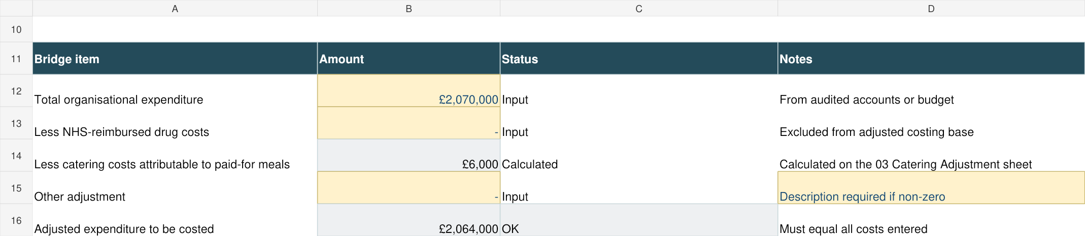
Figure 1. 02 Hospice Setup, A10:D16 — expenditure bridge. All names and figures are dummy data, not benchmarks.

Expenditure bridge / reconciliation — A10:D16
This reconciles consolidated accounts expenditure to the total used in the model. Differences should be limited to the specified adjustments – we recommend only adjustments for reimbursed drug and catering costs, but there is space for you to add another adjustment in exceptional circumstances. Avoid adding a balancing figure simply to make the workbook agree.
Cell | What to enter | Purpose and treatment
B12 | Total consolidated organisational expenditure | Enter total expenditure for the reporting period, including relevant trading subsidiaries. This is the starting point for reconciliation.
B13 | NHS-reimbursed drug costs | Enter drug expenditure reimbursed separately by the NHS. It is removed so reimbursed pass-through costs do not distort service comparisons.
B14 | Nothing — calculated from 03 Catering Adjustment, B16 | Removes the estimated catering cost attributable to meals paid for by staff, visitors or others. This is calculated on worksheet 3 – do not enter any data directly here
B15 | Other adjustment, only if genuinely necessary | Use exceptionally for a clearly defined cost outside the intended costing base. Explain the adjustment in D15. Do not use this simply to force the reconciliation to balance.
B16 | Nothing — adjusted expenditure | This is the expenditure that must be represented across 04 Service Costs, 05 Support & Income and 06 Shared Cost Pools.
C16 | Nothing — reconciliation status | OK means adjusted expenditure agrees to entered costs within £1. ERROR means costs are missing, duplicated or an adjustment is wrong.

Inpatient sites and beds — A19:T22
The model now has the ability to calculate costs for up to three different inpatient sites. Complete one row per physical inpatient site. Rows 20, 21 and 22 correspond to Sites 1, 2 and 3. Record the site name, activity status and operational bed count.
Column / cells | What to enter | Purpose; whether optional
B20:B22 | Site name | Essential for every active site. The name flows into results.
C20:C22 | Active? Yes or No | Select Yes only for sites operating during the reporting period(e.g. if you have two inpatient units C20 and C21 should be marked yes, C22 should be marked no).
D20:D22 | Total beds | Essential for active sites. Enter the number of physical beds available for use.
E20:E22 | IPU floor space (m²) | Include bedrooms and ancillary areas dedicated to the IPU, such as bathrooms, nursing/treatment rooms and lounges. Exclude other services, central offices and retail units. A reasonable estimate is acceptable.
F20:F22 | Standard hours, Extended hours or 24/7 | This data is used to allocate usage-sensitive estates costs. Standard hours means broadly an 8-hour working day; Extended hours means materially longer than a standard day but not continuous; 24/7 means the service operates continuously. For an IPU unit we’d expect the answer to always by 24/7 – as this is referring to the hours when patients are being cared for, not the hours when you accept admissions.
G20:G22 | Any beds dedicated by care type? | The model aims to calculate a cost for different types of IPU beds (e.g. specialist palliative care or CHC beds). Select Yes if particular beds are formally designated for specified care types; select No where beds are flexibly used according to caseload. (e.g You have 12 beds and 4 of them are reserved solely for CHC Fast Track funded beds. Select No if all beds are used interchangeably)
H20:J22 | Adult dedicated beds: specialist, CHC Fast Track, Step Up / Step Down / Enhanced | Complete only if G is Yes (i.e. if adult beds are dedicated by care type).
K20:L22 | Children’s dedicated respite and end-of-life beds | Complete only for children’s sites with formally designated beds and where G is Yes.
M20:M22 | Flexible / undesignated beds | If G is Yes, enter beds the number of beds that are not dedicated to one category. Dedicated plus flexible beds must equal total beds. If G is No, enter the total bed number here only if helpful; it is not required.
N20:N22 | Bed reconciliation | Calculated, do not enter data here. If you have specified that there is dedicated provision of a specific bed type, this cell should say OK when the analysis adds to the correct total.
O20:O22 | Notes | Optional. Explain unusual configurations, mid-year changes or how dedicated provision was interpreted.
P20:Q22 | Reporting-period days and calculated available bed days | Calculated from reporting dates and total beds.
R20:R22 | Override available bed days | Optional. Use where the simple beds × days calculation misstates capacity because beds were closed during the year or the number of beds changed during the year (note: only applies to beds that were closed for an extended period, not those that were simply unused).
S20:S22 | Available bed days used | Calculated result that flows to 09 Core Activity & Capacity.
T20:T22 | Reason for override | Required if R is used. State the cause and calculation, for example a ward closure or phased reopening.

Many hospices will not have dedicated beds for a particular type of patients in their IPU; instead the mix of how beds are used will change from week to week. The dedicated beds option is for those any who do have beds reserved for a particular patient cohort..
Example: a 12-bed site has 4 beds dedicated to CHC Fast Track and 8 flexible beds. Enter Yes in G, 4 in I and 8 in M. If all beds are used flexibly, select No in G; the optional enhanced care-type analysis can still be used.
(Note for hospices in Scotland & Northern Ireland: please use the CHC Fast Tack category for any generalize end of life / care around dying in your IPU – i.e. patients admitted primarily for care during the dying phase, where needs do not require complex specialist intervention).
Available bed days are beds × reporting-period days, including both start and end dates. R20:R22 is an optional override for closures, staffing constraints or a unit opening part way through the year. T20:T22 must explain any override. S20:S22 is the capacity used by the model; never overwrite its formula.
Figure 2. 02 Hospice Setup, A19:G22 — site information. All names and figures are dummy data, not benchmarks.

Services provided — A26:E50
Select Yes in column E only for those services that your hospice provided in the period.
Read the service definitions before choosing categories.
Use OTH_OTHER (row 50) if you have another charitable activity that cannot reasonably be classified within a defined service (an example of this might be a 24/7 advice line). Its full cost remains in reconciliation, but the model won’t calculate a cost per unit for it. Do not force such costs into another service merely to obtain a unit cost.

03 Catering Adjustment
The Catering Adjustment on Worksheet 3 removes the cost of meals paid for by staff & visitors.
Cell(s) | What to enter | Purpose and calculation
B6 | Total catering staff costs | Include employed and agency catering staff costs. Agency catering staff remain staff costs for this purpose.
B7 | Total catering non-staff costs | Include food, drink, equipment, outsourced supplies and other catering costs.
B8 | Number of paid meals | Count meals paid for by staff, visitors or others. Enter meal numbers, not sales income. Ideally do this for the year, but if not easily available it is acceptable to enter data for a representative month, week or day.
B9 | Number of meals provided without charge | Include patient meals and other hospice-funded meals. Ideally do this for the year, but if not easily available it is acceptable to enter data for a representative month, week or day.
B13:B16 | Calculated paid-meal proportion and removed costs | The model assumes paid and unpaid meals have the same average cost. B16 transfers to 02 Hospice Setup, B14.
B17:B18 | Calculated retained staff and non-staff costs | These flow automatically to the Catering lines on 05 Support & Income.
B19:C19 | Working status and explanation | OK means cost and meal inputs are usable. ERROR means costs exist but total meal numbers are missing or an input is negative.
Enter annual costs in B6:B7. Paid and free meal counts in B8:B9 must cover the same period as each other; a representative week, month or day is acceptable if the paid/free proportion is typical. The model applies that proportion to the annual costs. It assumes paid and free meals have the same average cost. If all meals are free, enter zero paid meals and the free-meal count. If there are no catering costs, leave B6:B9 blank. Do not enter the retained costs again on the support sheet: B17:B18 already link to 05 Support & Income, F27:F28.
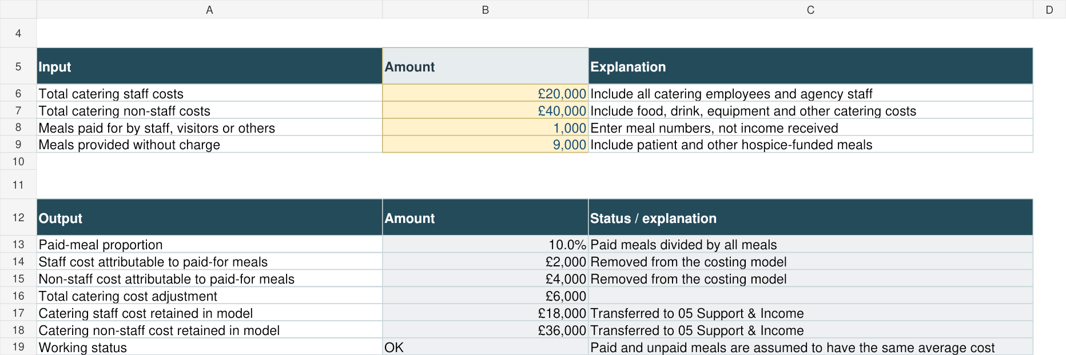
Figure 3. 03 Catering Adjustment, A4:D19 — catering working. All names and figures are dummy data, not benchmarks.

04 Service Costs
04 Service Costs is the first of the three worksheets where costs are entered. It is for costs attributable directly to a particular service. No costs should be entered against services that were classed as inactive.
Column / cells | What to enter / purpose
A5:C31 | Fixed service code, service/site name and Active? flag. If any of the active? Details are wrong in column C go back to worksheet 02 Hospice Setup to correct.
D5:D31 — doctors’ costs | Paid medical salaries, employer NI, pensions and other employment costs; paid locums and externally supplied medical cover.
E5:E31 — other staff costs | All other attributable employees, agency staff and employment on-costs (NI & pension), including nurses, HCAs, therapists and administrators working directly on a clinical service. Agency staff should be classified as staff costs even where accounts describe them as purchased services.
F5:F31 — non-staff costs | All other expenditure expenditure, such as supplies, travel etc that relates directly to a particular service.
G5:G31 | Calculated direct service total.
H5:H31 — source / explanation | Record relevant nominal codes, estimates or unusual treatments if this is useful for you to keep track of the data you have entered – this column is optional. Explain any negative cost.
I5:I31 — OPTIONAL medical input at no cost | Yes / No / Not known. This is an information column to help us understand the results – it explains whether externally funded medical input may affect comparison between hospices (e.g. some hospices may have doctors working in a service that the hospice does not pay for itself and so no cost is recorded in the model) . If left blank, we will take this as you have not answered the question, rather than specified no.. No monetary cost is added.
J5:J31 — OPTIONAL medical input note | Describe who supplies any free medical input mentioned above. This is for info only.
K5:K31 | Calculated status. Resolve errors and review incomplete active-service cost entries.
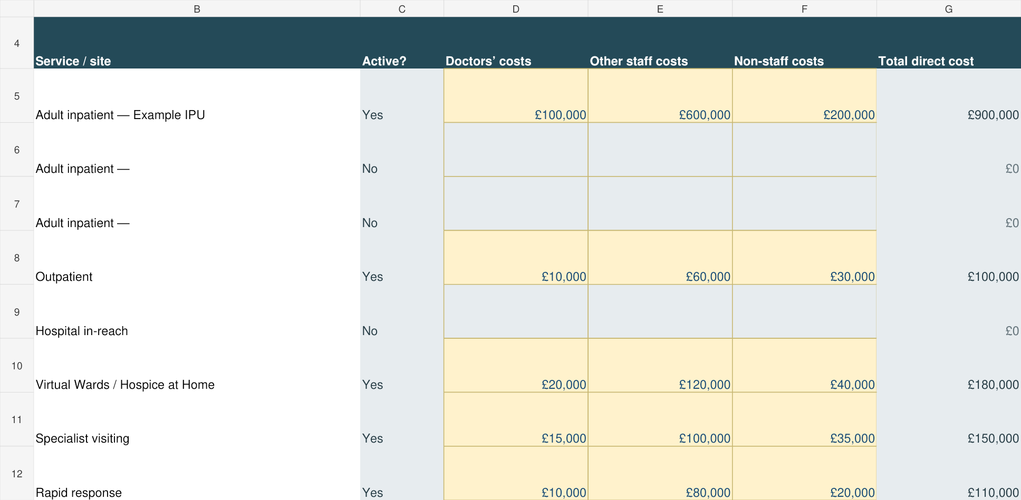
Figure 4. 04 Service Costs — doctors, other staff and non-staff entry. All names and figures are dummy data, not benchmarks.
If a member of staff works across services, use a defined shared pool (see section 6 for an explanation). Do not include the same cost both directly and in a pool.

05 Support & Income (Generation)
05 Support & Income is the second category for entering expenditure, with costs being entered as either staff or non-staff costs . Enter the total costs in F5:41. Do not enter anything in F27:F28 – this is the calculated catering costs from Worksheet 03 and cannot be edited. Column H is an optional notes column which users can use if they wish – e.g. to list the nominal codes they’ve used or other useful notes.
Function | Typical costs | Why the distinction matters
SUP08F — fixed estates and facilities | Rent, rates, depreciation, property insurance and fixed service charges. | These costs arise mainly from occupying space and are normally allocated by floor space.
SUP08U — usage-sensitive estates and facilities | Utilities, repairs, maintenance and grounds costs that increase with service use or operating time. | These are allocated using operating-hours-weighted floor space, so a 24/7 inpatient unit receives a larger share than a standard-hours service using the same area. (Note: ideally you would separate these two types of estate costs, but if not practical it is fine to put them all in either of those functions)

Retail, lottery and fundraising rows 31:41 are included to allow support costs to be allocated to them, but they do not affect the service costs. Include the relevant shop staff costs, premises, goods, prizes, contractors and fundraising costs under the existing headings.

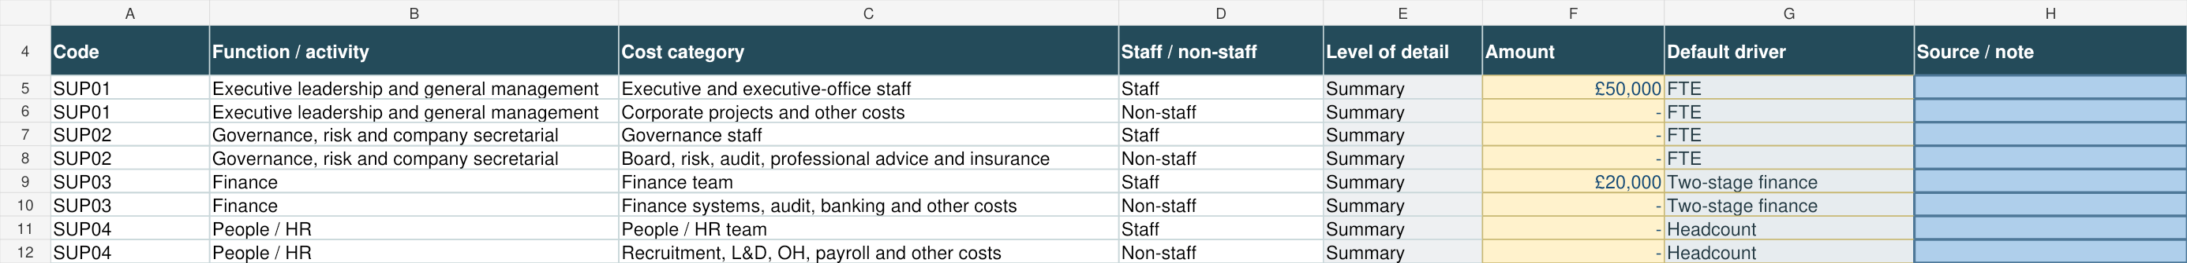
Figure 5. 05 Support & Income, A4:H12 — support cost entry. All names and figures are dummy data, not benchmarks.

06 Shared Cost Pools
06 Shared Cost Pools is the third and final category for cost input. It is for care costs that relate to more than one service – e.g. a quality governance team or the costs of a clinical director.
The model allows you to enter up to 12 shared pools, though it is anticipated that the average hospice is likely to only need a few. (The shared cost pool replaces the general clinical category that was used in the previous version of the model – it has been included due to feedback from hospices that they may have had more than one different type of general clinical cost, and that they want to allocate those costs in different ways).
There are two tables on the shared pool tab, both need to be completed for each pool you create.

Table 1: Create a pool — A4:J16
Cells | What to enter / purpose
B5:B16 | Give the pool a clear name, such as Shared clinical team.
C5:E16 | Enter the total costs for that pool, split between Doctors’ costs, other staff costs and non-staff costs for the period.
F5:H16 | These are calculated totals based on the info entered in this and the second table; don’t enter data here
I5:I16 | Explain the allocation basis– for example estimate of staff time, estimate of number of patients supported, or similar.
J5:J16 | Optional note if helpful for the user identifying included costs, local codes or material assumptions.

Table 2: Enter the details by which each pool is allocated to different services — rows 21:260
Column | What to do
B | Select the pool ID i.e. POOL01, POOL02, POOL03
C | Select each service (beneficiary category) from the drop down list. Use only one line per beneficiary category (e.g. if you want to allocate service POOL01 across three services, enter POOL01 in B21, B22 and B23 and then the three services you want to allocate costs to in C21, C22 and C23).
E | Enter the percentage of the pool’s cost you want to allocate to that service
H | Optional explanation for a weight or local assumption – enter an explanation if it is helpful
D, F:G, I:K | Calculated – do not enter data here – shows total allocation/status and the allocated doctors, other staff and non-staff split.
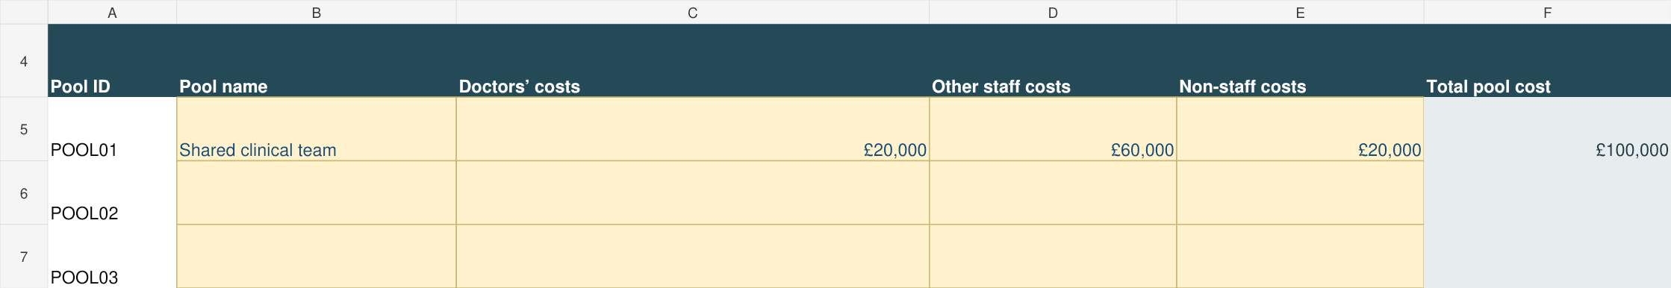
Figure 6. 06 Shared Cost Pools, A4:F7 — example clinical pool. All names and figures are dummy data, not benchmarks.
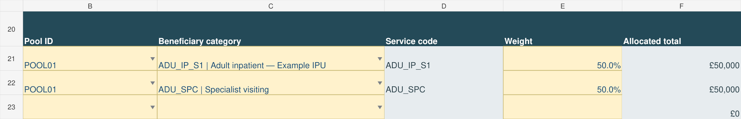
Figure 7. 06 Shared Cost Pools, B20:F23 — 50% / 50% beneficiary allocations. All names and figures are dummy data, not benchmarks.
Example: a £100,000 clinical pool contains £20,000 doctors, £60,000 other staff and £20,000 non-staff costs. A service receiving 50% receives £10,000 doctors, £30,000 other staff and £10,000 non-staff costs.

07 Support Drivers
Sheet 07 Support Drivers records the selected driver (allocation method) for each support function in D5:D17. In column C, a recommended default allocation method is pre-set. Users can over-ride this in column D if they feel another method is more appropriate for their service. Use only the permitted alternatives displayed for that function (these are available from a drop down list in column D), and explain any change in column E (E5:E17).
If you are content to use the default drivers, then you do not need to take any action on this worksheet.
Column | What to do | Purpose
A:C | Do not edit | Lists the different support functions and the default driver / allocation method
D5:D17 | Normally retain the default; select a permitted alternative if justified | Lists the selected allocation method.
E5:E17 | Explain every override | Required whenever selected driver differs from default. State why the alternative better represents resource consumption.
F:G | Do not edit | Shows support cost and total data available for the selected driver.
H | Do not edit; review status | ERROR - NO DRIVER DATA means the chosen driver has no usable values on 08 Allocation Data.
I | Do not edit | Lists permitted alternatives for that function.

An alternative allocation method should only be chosen where it better represents how services use the support function, or be a reasonable available proxy when the ideal driver cannot be obtained. It must not be chosen simply because it reduces a particular service’s cost.
Note: If you select direct costs as an allocation method, it means the overhead will be allocated in proportion to the direct costs. E.g. The direct costs of an IPU unit are £1,000,000 and for outpatient care are £250,000. HR Costs are £100,000 and you select the direct costs method to allocate them. HR costs will therefore be allocated across the two service in a ration of 4:1 (£80,000 to IPU and £20,000 to outpatients).
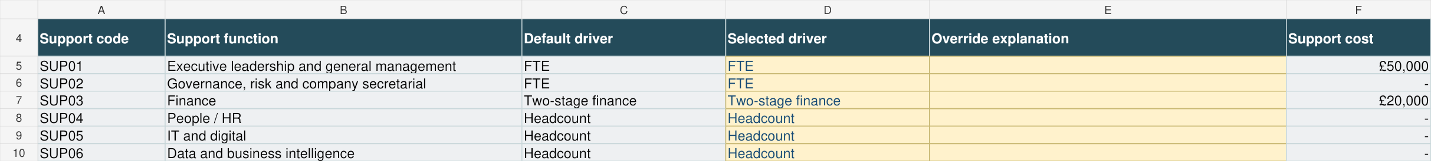
Figure 8. 07 Support Drivers — defaults and selected allocation methods. All names and figures are dummy data, not benchmarks.

08 Allocation Data
08 Allocation Data contains the information used to calculate the overhead allocations – e.g. staff numbers or floor space for the different service categories
Column C lists which services are active – only enter data against services which are labelled as active.
Check Active? in C before entering figures
An error will show in Column P if you enter data against an inactive service.
You only need to enter allocation / driver data for this allocation methods / drivers that you have selected for use . (e.g. if you are always using FTE for any staff allocations, you don’t need to complete the headcount column).
Column | Complete when | Purpose / definition
D — Headcount | Required where a selected support driver uses Headcount | Average number of people working in or supporting the recipient during the period. Use a consistent treatment of vacancies and agency workers.
E — FTE | Required where a selected driver uses FTE | Average full-time-equivalent workforce. Use the same reporting period and consistent contracted-hours basis.
F — Floor space | Required for Floor space or Weighted floor space | Usable floor space attributable to the recipient, excluding retail units, in square metres. Adult inpatient site values flow from 02 Hospice Setup.
G:H — Operating-hours band and factor | Required for Weighted floor space – this is to flag how approx. how many hours in a normal day a service operates, which may affect some usage sensitive facilities costs | Select either Standard hours factor (9-5), Extended hours, or 24/7
I — Weighted floor space | Calculated | Floor space multiplied by hours factor.
J — Cleaning hours | Required where Cleaning Hours is used to allocate housekeeping costs. | Either annual or representative shorter period (e.g. week) of cleaning hours attributable to the services). Include outsourced hours if relevant. (This is one of the more detailed aspects of the model and we recognize that not everyone will be able to easily provide it – if so just make sure you use an alternative allocating method such as floor space).
K — Meals | Required for Catering | Number of free meals provided to each service. Use the same meal definition as 03 Catering Adjustment.
L — Finance specific % | For retail, lottery, fundraising and governance where finance time can be identified | We think that many finance teams will spend a greater proportion of time supporting Income Generation. Enter the % of time finance spent supporting retail, lottery and fundraising. The balance is allocated automatically to other services using direct expenditure.
M — Direct costs | Calculated | Do not enter data - Used for direct-cost allocation where selected (see explanation at end of section 7 above)
N — Site | Optional except where helpful | You don’t need to enter data here - Adult inpatient site names flow automatically.
O — Notes | Optional | An optional free text box to explain estimates, shared premises or other material assumptions.
P — Inactive-data check | Calculated | Clear inputs if an inactive service shows ERROR - INACTIVE DATA.
Headcount counts people. FTE measures their working time: two staff each working half of full time total 1.00 FTE, while their headcount is two. Use a consistent reporting-period average. FTE is displayed to two decimal points so part-time staff can be accurately represented.
Site floor space and operating-hours bands in the first three inpatient rows link from Sheet 02 Hospice Setup. For other recipients, enter relevant floor space and the correct operating band. Exclude retail-unit floor space completely.
Cleaning hours may be reasonably estimated if reliable records are not available; if they cannot be estimated sensibly, select an appropriate permitted alternative for housekeeping.

Finance — L5:L34
The default remains a two-stage allocation. First enter any finance-time proportions that can reasonably be attributed to specific recipients, including fundraising, retail and lottery. Then the model allocates the remaining balance by direct expenditure (see explanation at end of section 7 above) among recipients without a specific allocation. The percentages entered must not exceed 100%.
Use reasonable estimates; do not create a formal timesheet exercise solely for this model. Zero is an acceptable answer where you do not believe your finance team spends a disproportionate amount of time supporting income generation.
Figure 9. 08 Allocation Data — workforce and usage information. All names and figures are dummy data, not benchmarks.

Sheet 09 Core Activity & Capacity
09 Core Activity & Capacity is the place to enter capacity and activity data for the different services.
Activity is what was delivered; capacity is the operationally staffed and available amount that could have been delivered.
Rows 6:44 are for entering the core capacity and activity data, and rows 72 and 73 is for additional data about hours of care delivered for hospice at home.
Rows 50:69 and 74 is for optional data about the number of unique individual patients supported in the year for each service.

Adult inpatient — F6:F14
Capacity in F6, F9 and F12 links to the three sites’ available bed days. Enter annual occupied bed nights in F7, F10 and F13. Enter admissions in F8, F11 and F14 if available. Admissions are episodes, including repeat stays, rather than unique patients (i.e. if a patient was admitted to the IPU 3 times, count them 3 times)

Outpatients — F15:F16 and G15
This is an area where it may be difficult to calculate meaningful capacity. For F15, use available booked appointment slots only where they are a meaningful capacity measure and cover the same scope as the attendances. If drop-in activity, variable appointment lengths or another service feature makes that comparison unreliable, leave F15 blank and optionally explain why in G15.
Enter attendances in F16 even if capacity is unavailable. When capacity is blank, the model still reports full cost and cost per attendance; required.

Other core services — rows 17:44 and 72:73
Follow each service type and measure as listed in columns C:E for each service and enter the numbers as appropriate: contacts, care hours, attendances or occupied bed nights.

Children’s respite and end-of-life care — F32:F37
Enter occupied bed nights for respite in F33 and for end-of-life care in F37. (Note: we are looking for occupied bed nights, not day visits or number of admissions).
Enter available bed-night capacity in F32 and F36. Where beds are shared (between respite and end of life care), estimate the capacity reasonably between the two services once only. Do not double count the full shared capacity against both categories (e.g. if you have 6 beds in total that are used flexibly, you might enter 5 for respite and 1 for end of life care – don’t enter 6 for both services).
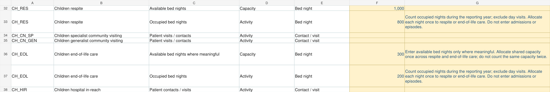
Children’s worked example: annual occupied bed nights are entered separately for respite and end-of-life care. All figures are dummy data.
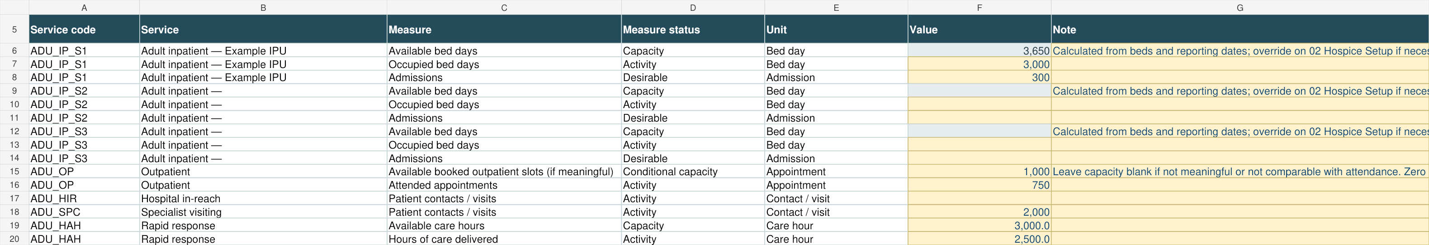
Figure 10. 09 Core Activity & Capacity, A5:G20 — core inputs. All names and figures are dummy data, not benchmarks.

OPTIONAL annual unique service users — F50:F69 and F74
If hospices enter data here it will allow us to calculate an additional cost-per-service-user result (as well as the cost per capacity or activity). It is separate from workload: someone receiving 20 community contacts counts as one person.
Rule | How to apply it
One count within each service | Count each person once within each service, even if they had many contacts, appointments, visits or attendances.
More than one service | The same person may be counted once in more than one service. For example, a patient using both lymphoedema and living-well services appears once in each service count.
Bereavement and family support | Count the family member, carer or other individual who directly received the support; do not count the deceased patient unless they also personally received that service.
Reporting-period count | Count everyone who used the service during the reporting period, not only those on the caseload at year end.
Data unavailable | Leave the cell blank if a reasonably reliable unduplicated count cannot be produced. The rest of the model will still work, but cost per service user will remain blank for that service.
These counts measure reach, not intensity or complexity. Differences in support per person may explain differences in cost per user. Do not add the individual service counts to obtain a hospice-wide unique-patient total because the same person can use several services. Leave a count blank if a reasonably reliable unduplicated figure cannot be produced; the model will still work it just won’t be able to produce only a unit-cost result per service user.
Figure 11. 09 Core Activity & Capacity, A49:G54 — optional unique users. All names and figures are dummy data, not benchmarks.

Sheet 10 Optional IPU Care Type
The previous version of the model returned a surprising range of cost per night of inpatient care, which we believe must be because hospices are operating different service models. This optional working is a little complex, but we think there will be significant value if hospices are able to complete it. We recognize that this will take some additional work and not all hospices will have the detail to complete it, but where it is possible we believe the result will be valuable in helping us understand the variation in IPU costs.
If hospices enter date here this enables us to calculate separate adult inpatient cost per occupied bed night for specialist palliative care, CHC Fast Track (note for hospices in Scotland / N Ireland: equivalent to patients admitted during the dying phase where needs do not require complex specialist intervention) and Step Up / Step Down / Enhanced care (as opposed to a single IPU bed night cost).
It aims to help explain understand and explain why overall IPU costs can vary so much from hospice to hospice
Complete one row in each of the tables for each inpatient site you use – see below for the info needed for each table . One patient occupying a bed for one night counts as one occupied bed night.

Annual occupied bed nights — D12:F14
For each site, to be able to complete this additional working, you will need information from your clinical team a to the type of care provided to patients in each bed throughout the year. (E.g. If you had 2,000 occupied bed nights in the year, these could have comprised 900 bed nights occupied for Specialist Palliative Care, 800 bed nights occupied for CHC Fast Track and 300 for Step Up / Step Down / Enhanced)
Enter the annual occupied bed nights for each of the three care types in columns D–F. Together, these must equal the site’s annual total already entered on worksheet 9.
Figure 12. 10 Optional IPU Care Type, A8:J14 — annual bed-night mix. All names and figures are dummy data, not benchmarks.

Choose an evidence period — C20:D22
In order to calculate the cost of care for the different types of IPU services, we also need to understand how much time staff are spending supporting patients receiving different types of inpatient care (i.e. the care intensity experience)
This is likely to be challenging for hospices to do for the full year, so we’ve included the option for hospice to do this for a shorter period for reasons of practicality – e.g. a week or a month.

In column C, choose whether you can provide nursing and care information for the full year, a representative month or a representative week. For a week or month, enter its start date in column D. Choose a period that reflects the site’s usual care requirements.
Input | What to enter | Purpose
C20:C22 | Representative week, Representative month or Full reporting year | Defines the period for the care-intensity evidence. Choose a period that is reasonably typical; avoid an unusual outbreak, closure or extreme staffing event unless it reflects normal operations.
D20:D22 | Start date for a week or month; blank for full year | Allows the model to calculate effective start and end dates and documents exactly which sample was used.
Figure 13. 10 Optional IPU Care Type, A19:G22 — evidence period. All names and figures are dummy data, not benchmarks.

Selected-period bed nights — C28:F30
The third table on the worksheet is doing the same thing as the first table – analysing occupied bed nights across the three different types of inpatient care.
The difference is that the first table is always for the full year data, whereas the table in rows 28:30 is for whatever time period you selected in the second table (i.e. it might be a week or a month)
For a week or month, enter the total and the three-category split in C:F.
For a full year, leave these cells blank: G:J use annual figures automatically.
Figure 14. 10 Optional IPU Care Type, A27:F30 — sample bed nights. All names and figures are dummy data, not benchmarks.

Selected-period nursing/care hours — C36:F38
Finally, the fourth table asks for an estimate of nursing time across the three types of inpatient support during the period in question (week / month / year).
E.g. If you selected a representative week, you might find that staff spend proportionally more time supporting specialist palliative care patients than those receiving CHC funded healthcare.
Enter total nursing/care hours and the three-category split for the same site and dates. Include direct patient care delivered by nurses, HCAs and similar staff; exclude doctors and central support time. Apply a consistent method across care types and explain estimates or exclusions in the optional Method / note column N. Check reconciliation in I.
A good estimate of how staff spent their time over a representative week is acceptable for the purposes of this calculation and we recognized that you might need to select a week outside the reporting period (i.e. you might need to do this for a week at the time you are completing the model rather than for the last financial year).
Figure 15. 10 Optional IPU Care Type, A35:F38 — sample nursing/care hours. All names and figures are dummy data, not benchmarks.

11 Optional Community
Worksheet 11 is also optional, and if it is not completed it will not affect the overall model results. It has been included based on member feedback to try to give a more detailed estimate of community costs.
It estimates separate telephone and face-to-face contact costs for six adult community services: the three specialist-at-home categories, generalist HCA visiting, generalist nursing visiting and domiciliary/home care. Complete only active services for which annual contact counts and staff-time estimates are meaningful.

Choose a staff-time method — C8:C13
For each service you want to analyse, choose whether you will enter total staff hours or average staff minutes per contact. If you already know the service’s total direct staff hours, you can enter these in column D as an optional check; otherwise leave it blank.

Method | Use when | What the model does
Total direct staff hours | You have recorded data about how much time staff have spent during the year for telephone versus face-to-face contacts (We suspect this might be rare) | Uses the category totals entered in G19:G30.
Average minutes per contact | You don’t have the above data but can estimate a reasonable average direct staff time for telephone versus face to face contacts | Multiplies contacts by minutes and divides by 60 to calculate category hours.

Include the combined paid time of staff involved in a contact (i.e. if two staff carry out a half hour visit, this counts as an hour)

OPTIONAL independent total hours — D8:D13
This is an additional optional check: enter the service’s total direct staff hours if known. Otherwise leave blank—the analysis will still work
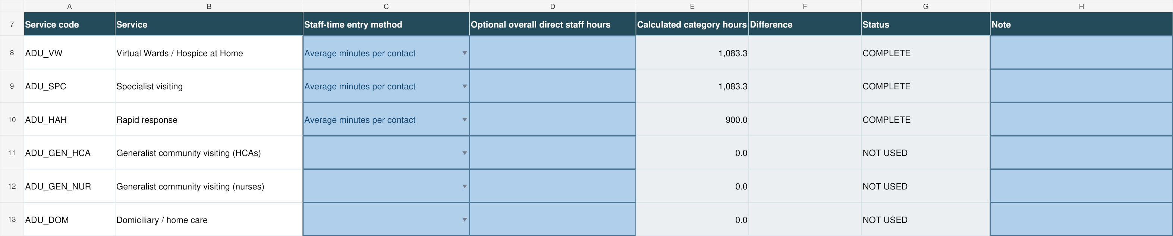
Figure 16. 11 Optional Community, A7:H13 — entry method and optional total. All names and figures are dummy data, not benchmarks.

Contacts and paid staff time — F19:H30
For each service, enter the annual number of telephone contacts and face-to-face contacts. Then enter either the total staff hours spent on each contact type or the average staff minutes per contact, according to your choice in C8:C13. Include the time of all paid staff involved: two staff spending 30 minutes on one contact means 60 staff minutes.
Together, these tables allow the model to estimate separate costs for telephone and face-to-face contacts, reflecting the different amounts of staff time they require.

Column | What to enter | Purpose
F — Number of contacts | Annual telephone or face-to-face contacts for the service. Use mutually exclusive categories so each contact is counted once. | Provides activity totals and allocates non-staff/other costs by contact share.
G — Total direct staff hours | Complete only if the selected method is Total direct staff hours. | Provides relative direct staff resource use.
H — Average direct staff minutes / contact | Complete only if the selected method is Average minutes per contact. Include direct time reasonably attributable to the contact; use a consistent definition for both categories. | Converted to calculated hours in I.
I — Calculated direct staff hours | Do not edit. | Used to allocate direct staff cost.
J — Status | Do not edit. | Costs are withheld until staff-time information is provided for each populated contact category.

Where several paid staff attend together, count one contact and include all their paid direct time.
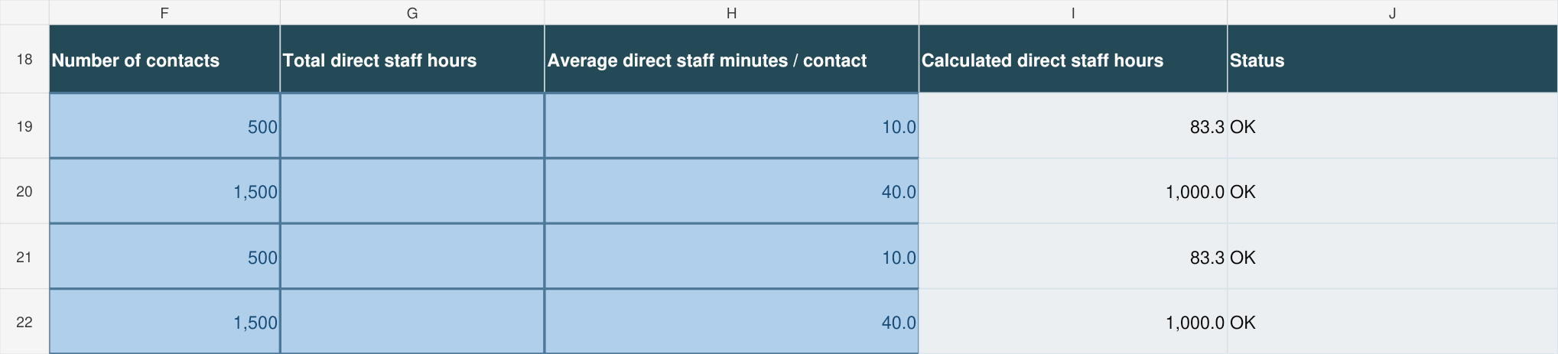
Figure 17. 11 Optional Community, F18:J22 — contact/time inputs; Virtual Wards first, then Specialist visiting. All names and figures are dummy data, not benchmarks.

12 Checks & Completion
12 Checks & Completion, A4:G28, is the live reconciliation and validation page. Resolve every ERROR. Review warnings and explain the underlying input or assumption in the relevant input sheet’s note field.
If you can’t resolve an error email your draft model to c.duncan@hospiceuk.org for help.
Rows | Check | Typical resolution
5 | Required setup | Complete organisation, reporting dates and expenditure.
6 | Adjusted expenditure versus costs entered | Find missing, duplicated or excluded costs.
7 | Pre- versus post-allocation | Check for allocation formula/data issues; normally this should reconcile automatically.
8 | Shared pools | Complete every pool line and make weights total 100%.
9 | Finance time | Reduce specific finance percentages if total exceeds 100%.
10:11 | Service-cost validation | Explain negative costs or clear inactive-service cost inputs.
12 | Dedicated beds | Make dedicated plus flexible beds equal total beds.
13 | Catering | Complete meal data where catering costs exist.
14 | Other adjustment | Review and explain any amount.
15 | Support allocation settings | Select a valid driver, enter driver data and explain overrides.
16:18 | Care-type enhanced analysis | Correct incomplete reconciliations if the optional method is used.
19 | Inactive service data | Clear inputs against inactive services.
20 | Inpatient capacity overrides | Add reasons for all overrides.
21 | Model completion | READY FOR REVIEW means no error-status checks remain.

READY FOR REVIEW means the error-status checks have passed. If you have error messages and are struggling to resolve them please email the partially completed model to c.duncan@hospiceuk.org who will be able to advise you what is needed to fix the error.
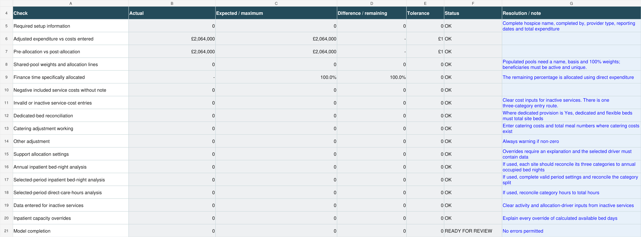
Figure 18. 12 Checks & Completion, A4:G21 — reconciliation and validation. All names and figures are dummy data, not benchmarks.

13 Results Dashboard
13 Results Dashboard, A10:M35, gives headline direct, shared, central support and full cost, together with capacity, activity and unit costs.
Measure | Meaning
Direct cost | Cost entered directly against the service.
Shared cost | Amount allocated from defined 06 Shared Cost Pools.
Support cost | Allocated organisational support cost.
Full cost | Direct + shared + allocated support (excluding any income-generation reallocation)
Cost / capacity | Full cost divided by operational capacity.
Cost / activity | Full cost divided by actual activity.
Utilisation | Activity divided by capacity where both measures exist.
Admissions / service users | IPU rows: number of admissions. Other services: annual unique individuals within that service.
Cost / admission or service user | Full service cost divided by the relevant denominator. IPU values are cost per admission, not cost per unique patient. Blank when no denominator is supplied.
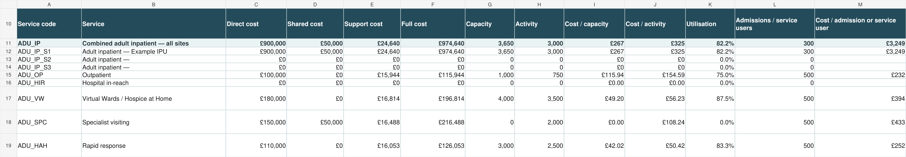
Figure 19. 13 Results Dashboard — headline service costs. All names and figures are dummy data, not benchmarks.

14 Detailed Results
14 Detailed Results, A4:S35, provides the full service list and audit breakdown.
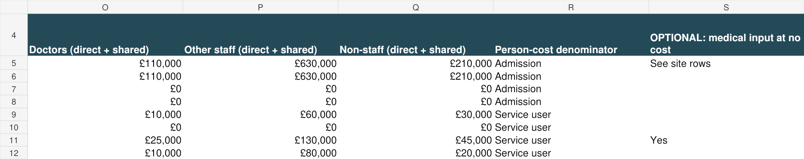
Figure 20. 14 Detailed Results, O4:S12 — cost categories and denominator labels. All names and figures are dummy data, not benchmarks.

15 Enhanced Analysis
Worksheet 15 Enhanced Analysis shows the results of the optional enhanced analysis from worksheet 10 (different types of IPU care) and 11 (different types of community care).
It will therefore only show results where you have completed this optional additional analysis.
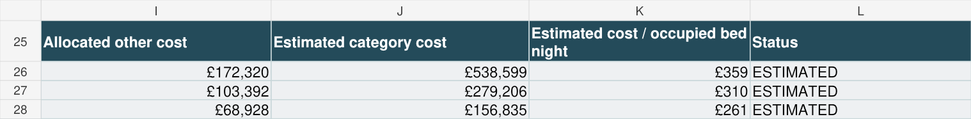
Figure 21. 15 Enhanced Analysis, I25:L28 — IPU estimates: specialist, CHC Fast Track, step-up/step-down/enhanced, top to bottom. All names and figures are dummy data, not benchmarks.
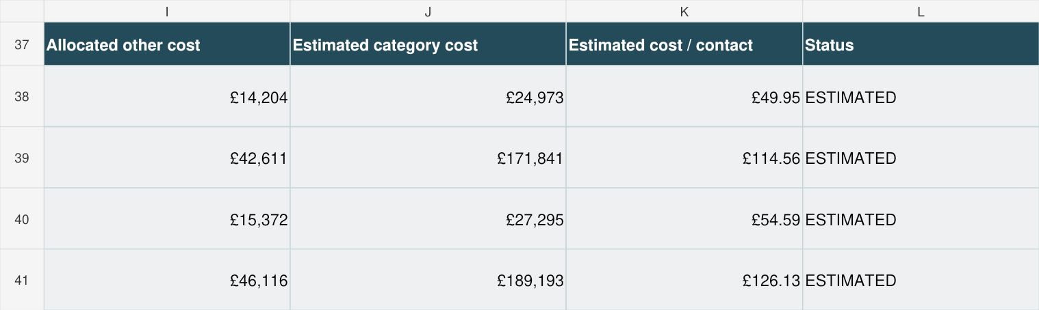
Figure 22. 15 Enhanced Analysis, I37:L41 — telephone then face-to-face estimates for Virtual Wards, then Specialist visiting. All names and figures are dummy data, not benchmarks.

16 Calculations
This is a working file, where the model performs the key calculations. It is hidden by default. No user input is required and editing it may break the model!

17 Code Lists
This is another working file, containing the various codes used to classify services. It is hidden by default. No user input is required and editing it may break the model!

18 Standard Export
Hidden by default. This worksheet put the results into a standard format to help Hospice UK analyse the result. No user input is required and editing it may break the model!

Service definitions
The definitions below describe the agreed service categories. Choose the service boundary that describes actual provision, and apply it consistently to costs, activity, users and shared allocations.

Adult services
Code | Service | Definition
ADU_IP | Adult inpatient | Care delivered within the hospice inpatient unit. Costs are recorded separately for up to three sites; optional care-type analysis is recorded separately.
ADU_OP | Outpatient | Planned outpatient/day-clinic activity not included in Living well.
ADU_HIR | Hospital in-reach | Hospice staff providing specialist input to patients or teams in hospital (A&E or wards).
ADU_VW | Virtual Wards / Hospice at Home | Meeting national criteria for highly complex management at home
ADU_SPC | Specialist visiting | Delivered by a team overseen by advanced care practitioners in the patient’s home
ADU_HAH | Rapid response | Urgent assessment and symptom management in the patients home within target response time.
ADU_GEN_HCA | Generalist community visiting (HCAs) | Delivered by a team of HCA’s who provide personal care and basic nursing tasks in the patients home
ADU_GEN_NUR | Generalist community visiting (nurses) | Delivered by a team overseen by registered nurses in the patients home
ADU_DOM | Domiciliary / home care | Specifically commissioned personal and practical care
ADU_LYM | Lymphoedema | Assessment and treatment of lymphoedema.
ADU_BER | Bereavement | Bereavement support for adults, families or carers.
ADU_FAM | Family and carer support | Support for family members and carers not classified as bereavement.
ADU_LW | Living well services | Rehabilitation, wellbeing, day and group activities helping patients live well.

Children’s services
Code | Service | Definition
CH_RES | Respite | Planned inpatient or overnight respite.
CH_CN_SP | Specialist community visiting | Delivered by a team overseen by advanced care practitioners in the children’s homes
CH_CN_GEN | Generalist community visiting | Delivered by a team overseen by advanced care practitioners in the patient’s home
CH_EOL | End-of-life care | End-of-life care in the inpatient unit
CH_HIR | Hospital in-reach | Hospice staff supporting children, families or teams in hospital.
CH_TH | Therapies | Physiotherapy, occupational, creative or other therapy services.
CH_FS | Family support | Support for parents, siblings and family members.
CH_BER | Bereavement services | Bereavement support.
CH_DAY | Day services | Planned day attendance and activities, play therapy etc.

Other charitable activity
OTH_EDU is education and OTH_RES is research – these represent charitable activities which might have costs for many hospices but where we are not trying to calculate a unit cost
OTH_OTHER is a catch all category if your hospice operates a service that is genuinely not covered by any of the exiting categories. A 24/7 advice line might be an example of one such service. Enter costs of any such services under this other category.

Troubleshooting
(Or email the draft model to c.duncan@hospiceuk.org who will be able to help you)
Problem | Action
Costs do not reconcile | Compare 02 Hospice Setup B16 with 12 Checks & Completion C6. Check 04 Service Costs G5:G31, 05 Support & Income F5:F41 and 06 Shared Cost Pools F5:F16 for omissions or duplication.
Inactive-service error | Check the service in 02 Hospice Setup. Activate it only if it was provided; otherwise clear its cost, activity and driver inputs.
Shared-pool error | Check the pool name and basis, complete each beneficiary, use active services once per pool and make weights total 100%.
No support-driver data | Complete the relevant 08 Allocation Data column or choose a permitted, justified alternative in 07 Support Drivers.
Outpatient utilisation is blank | This is expected if meaningful, comparable capacity is unavailable. Cost per attendance can still be calculated.
IPU estimated costs are unavailable | Complete annual bed nights, valid period settings, matching sample bed nights and nursing/care hours. Check any override is within the other-staff cost base.
Community costs are blank | Choose the time method and supply usable paid staff time for each populated contact category.
Community unit costs are equal | Check average time per contact. Equal implied paid time may legitimately produce equal costs.
Cost per user/admission is blank | Supply admissions for IPU or a reliable annual unique count for the relevant non-IPU service. A blank count is not zero.
Cannot edit a cell | Grey formulas and labels are protected. Enter data in yellow/blue cells; inspect formulas by selecting the cell. Request an unlocked working copy only if necessary.

Final completion checklist
- Organisation, reporting period and active services are correct.
- Adjusted expenditure reconciles to costs entered; every exceptional adjustment is explained.
- Doctors, other staff and non-staff costs are complete for active services, with no duplicate shared costs.
- Catering and central support/income-generation costs are complete.
- Shared pools have documented beneficiaries, evidence and 100% weights.
- Selected support drivers have usable data; every override is justified.
- Activity and meaningful capacity cover the same reporting period and service scope.
- Optional unique counts are unduplicated within each service; IPU admissions are interpreted as episodes.
- Optional analyses are blank or based on coherent, reconciled evidence.
- Checks show READY FOR REVIEW; remaining warnings and missing-result messages have been reviewed.
- Headline and detailed results are plausible in light of the service model, utilisation and free medical input.
- Save with hospice name and reporting year and return the workbook to c.duncan@hospiceuk.org.

